**LIEUTENANT COLONEL R K K PARAGAHATHANTHREE psc SLAC (O/64918)**

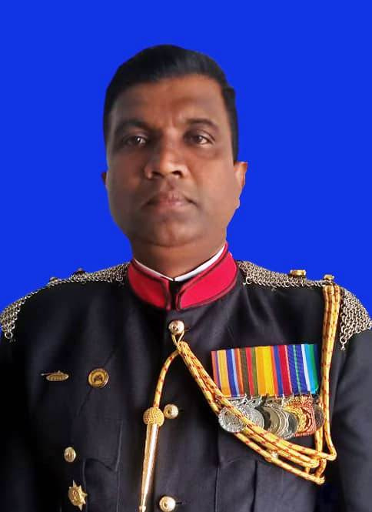**SERVICE RECORD**:

Date of Enlistment : 11.10.1998

Intake : 51B

Date of Commission : 11.10.2000

Date of Birth : 12.02.1978

Previous Bn : 3 SLAC

Full Name : RKK Paragahathanthree

First Name : Ravindra

Religion : Roman Catholic

Personal Address : No 37, Bopitiya, Pamunugama, Jaela

School Attended : Pamunugama Maha Vidyalaya, De Mazenod College, Kandana

|  |  |  |  |  |  |
| --- | --- | --- | --- | --- | --- |
| **SER** | **APPT** | **COURSES** | **LOC** | **PERIOD** | |
| **FROM** | **TO** |
| **Second Lieutenant - 11.10.1998** | | | | | |
| 1. | Tpr Ldr |  | 3 SLAC | 19.06.2002 | 30.11.2003 |
| 2. | A/Adjt |  | 3 SLAC | 28.12.2003 | 06.02.2004 |
| **Lieutenant - 11.04.2002** | | | |  |  |
| 3. |  | Local YOs Armor | ACTC | 18.03.2003 | 21.05.2003 |
| 4. | Tp Ldr/A/Adjt |  | 1 SLAC | 07.02.2004 | 03.02.2006 |
| **Captain - 11 .04.2005** | | | | | |
| 5. | Adjt |  | 1 SLAC | 03.02.2006 | 10.07.2006 |
| 6. |  | Young Officer Course | India | 10.07.2006 | 30.12.2006 |
| 7. | Adjt |  | 1 SLAC | 30.12.2006 | 07.01.2008 |
| 8. | OC ‘A’ Sqn |  | 1 SLAC (VLN) | 10.01.2008 | 13.10.2008 |
| 9. | OC ‘D’ Sqn |  | 1 SLAC (JFN) | 13.10.2008 | 02.04.2009 |
| 10. | ADC to Maj Gen GA Chandrasiri |  |  | 03.04.2009 | 14.08.2009 |
| 11. | OC ‘A’ Sqn |  | 6 SLAC (Nagarkovil) | 14.08.2009 | 24.09.2009 |
| 12. |  | Trg | Kukulagaga | 28.09.2009 | 16.10.2009 |
| 13. | Departure from Sri Lanka |  | Haiti | 08.11.2009 |  |
| 14. |  | Reached | Haiti | 09.11.2009 |  |
| 15. |  | Mission |  | 09.11.2009 | 26.05.2010 |
| 16. | Departure |  | Haiti | 27.05.2010 |  |
| 17. | Arrival |  | Sri Lanka | 28.05.2010 |  |
| 18. | Leave |  |  | 29.05.2010 | 18.06.2010 |
| **Major - 30.09.2009** | | | | | |
| 19. | OC ‘D’ Sqn |  | 6 SLAC (Nagar Kovil) | 13.07.2010 | 20.11.2010 |
| 20. |  | IH and HRL Course |  | 21.08.2010 | 09.09.2010 |
| 21. | OC ‘D’ Sqn |  | 6 SLAC (Panama) | 20.11.2010 | 24.10.2011 |
| 22. |  |  | OCDC | 24.10.2011 | 19.11.2011 |
| 23. |  | English Course | KDU | 21.11.2011 | 23.12.2011 |
| 24. |  | Staff Course | DSCSC | 03.01.2012 | 20.01.2012 |
| 25. |  | Course Officer | SLMA | 03.01.2013 | 11.07.2013 |
| **SRL** | **APPT** | **COURSES** | **LOC** | **PERIOD** | |
| **FROM** | **TO** |
| 26. | OC GAN Coy |  |  | 11.07.2013 | 30.09.2013 |
| 27. |  | Instructor Law of Armd Conflict | Malaysia | 30.09.2013 | 11.10.2013 |
| 28. | OC GAN Coy |  |  | 11.10.2013 | 21.07.2014 |
| 29. |  | Armour Instr | India | 04.08.2014 | 18.10.2014 |
| 30. | OC ‘A’ Sqn |  | 3 SLAC | 07.11.2014 | 12.06.2015 |
| 31. | OC HQ Sqn |  | 3 SLAC | 12.06.2015 | 15.01.2016 |
| 32. | SO 2 |  | Regtl Centre | 19.01.2016 | 22.05.2017 |
| 33. | POSOC 23 |  |  | 08.02.2016 | 04.03.2016 |
| 34. |  | UN Military Expert on Mission | Australia | 09.09.2016 | 10.07.2016 |
| 35. |  | UN Msn Trg | IPSOTS | 20.02.2017 | 22.05.2017 |
| 36. | GSO II (Ops) |  | Dte of Ops | 22.05. 2017 | 07.10.2018 |
| 37. |  | Track and Armoured Eqpt Course | China | 07.10 .2018 | 09.07.2019 |
| 38. | SO2 (Supply and Maint) |  | MGO BR | 20.08.2019 | 11.11.2019 |
| 39. | 2IC |  | 5 SLAC | 28.11.2019 | 06.01.2021 |
| 40. | RHQ SLAC |  |  | 01.06.2021 | 01.03.2021 |
| 41. |  | JSC & MCC | Pakistan | 01.03.2021 | 22.07.2021 |
| 42. | RHQ SLAC |  |  | 22.07.2021 | 17.09.2021 |
| 43. |  | CT Course | India | 18.09.2021 | 15.10.2021 |
| 44. | RHQ SLAC |  |  | 19.10.2021 | 09.01.2022 |
| 45. |  | IH and HRL Advance Course IPSOT |  | 10.01.2022 | 15.02.2022 |
| **Lieutenant Colonel - 04 Feb 2022** | | | | | |
| 46. | GSO I (Coord) |  | HQ 51 Inf Div | 24.02 .2022 | 22.04.2022 |
| 47. |  | Snr Comd Course | AWC | 23.04.2022 | 08.08.2022 |
| 48. | GSO I (Coord) |  | HQ 51 Inf Div | 09.08.2022 | 30.11.2022 |
| 49. | GSO I (Ops) |  | HQ 51 Inf Div | 01.12.2022 | 21.03.2023 |